**NBTX10442_LAB-A_WEEK-7**

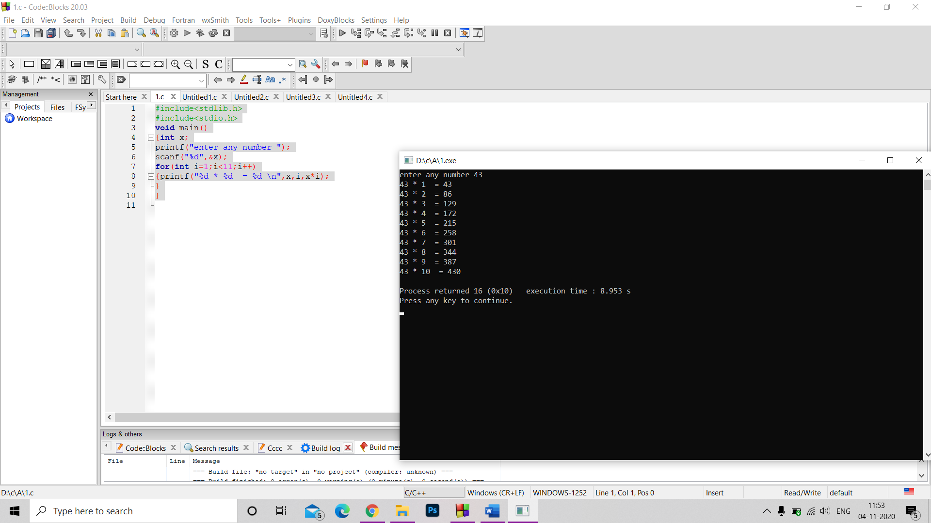Q1. #include<stdlib.h>

#include<stdio.h>

void main()

{int x;

printf("enter any number ");

scanf("%d",&x);

for(int i=1;i<11;i++)

{printf("%d * %d = %d \n",x,i,x*i);

}

}

Q2. #include<stdlib.h>

#include <stdio.h>

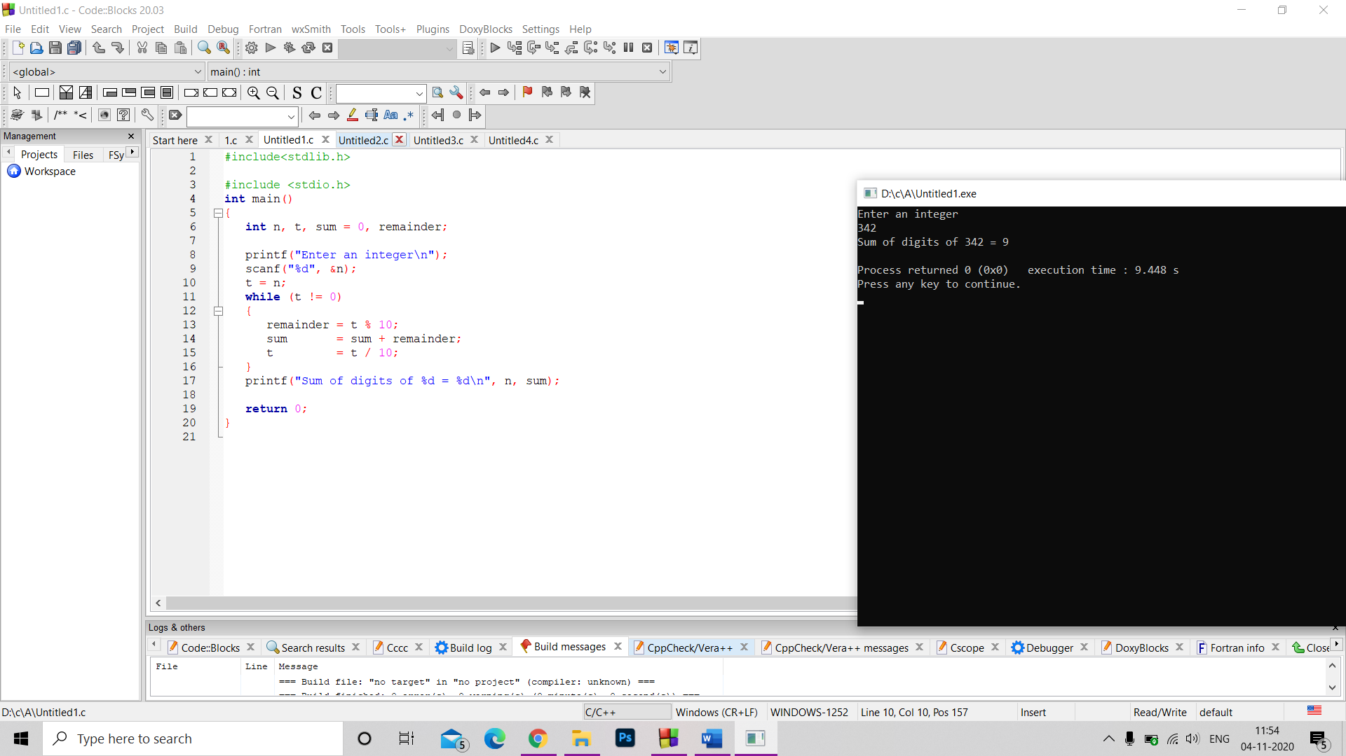int main()

{

int n, t, sum = 0, remainder;

printf("Enter an integer\n");

scanf("%d", &n);

t = n;

while (t != 0)

{

remainder = t % 10;

sum = sum + remainder;

t = t / 10;

}

printf("Sum of digits of %d = %d\n", n, sum);

return 0;

}

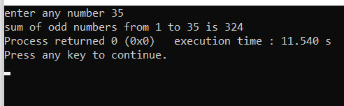

Q3. #include<stdlib.h>

#include<stdio.h>

int main()

{int x,s=0;

printf("enter any number ");

scanf("%d",&x);

for(int i=1;i<=x;i=i+2)

{

s+=i;

}

printf("sum of odd numbers from 1 to %d is %d",x,s);

}

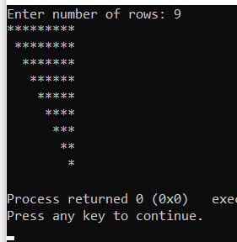Q4. #include <stdio.h>

int main()

{

int i, j, rows;

printf("Enter number of rows: ");

scanf("%d", &rows);

for(i=1; i<=rows; i++)

{

/* Print leading spaces */

for(j=1; j<i; j++)

{

printf(" ");

}

/* Iterate through columns to print star */

for(j=i; j<=rows; j++)

{

printf("*");

}

printf("\n");

}

}

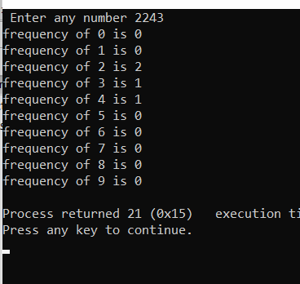Q5. #include<stdlib.h>

#include<stdio.h>

void main()

{

int a,b1,count=0,c[10]={0,0,0,0,0,0,0,0,0,0};

printf(" Enter any number ");

scanf("%d",&a);

while(a>0)

{ b1=a%10;

a=a/10;

c[b1]++;

}

for(int i=0;i<10;i++)

printf("frequency of %d is %d \n",i,c[i]);

}